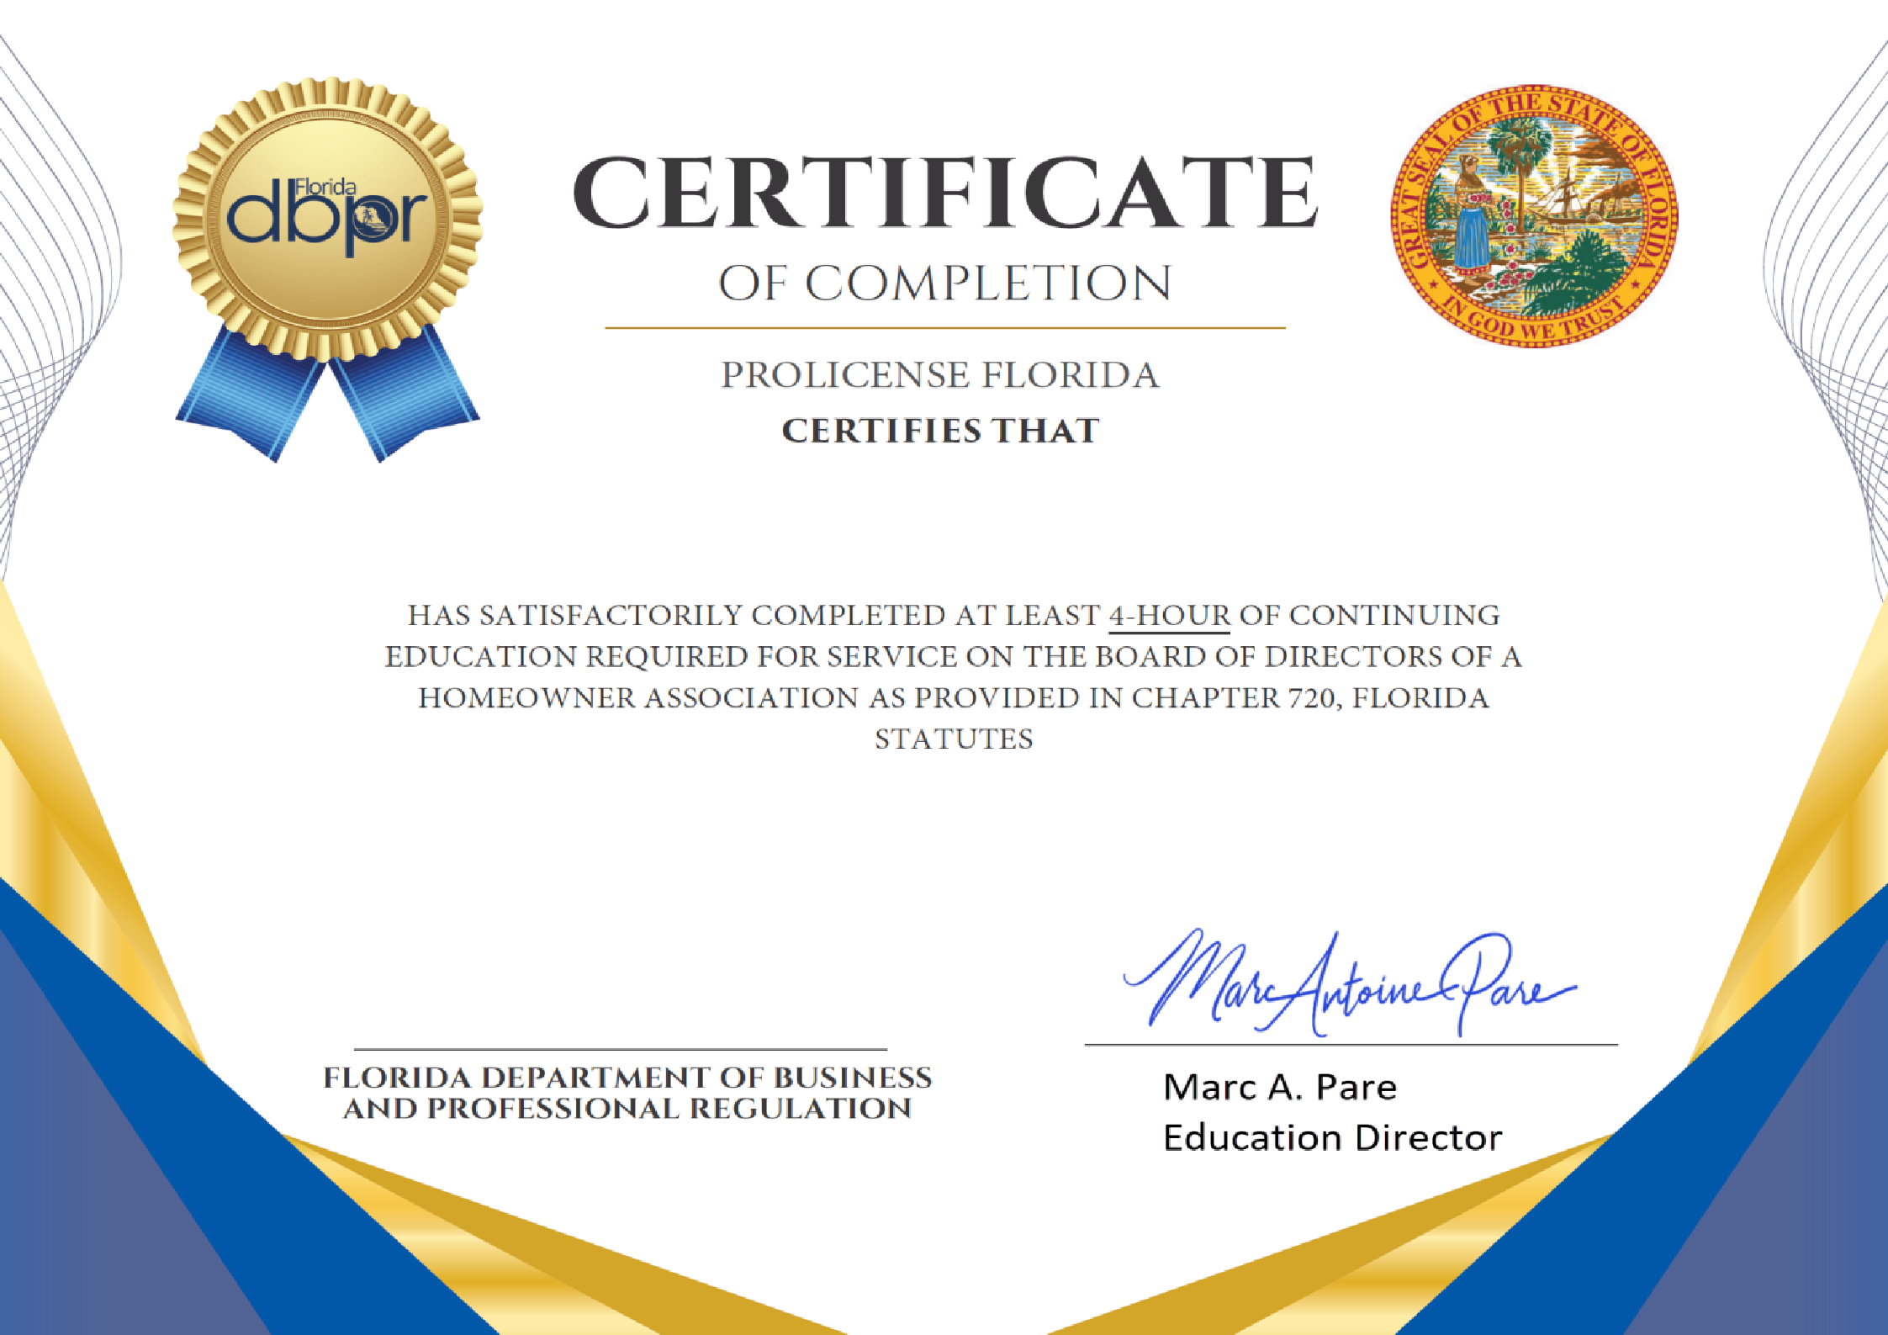

michael lica

HOA Board Director Continuing Education (4-Hrs)

Completion Date: 07/22/2026

