CYPRESSLAKES HOMEOWNERS' ASSOCIATION, INC.
Veteran's Building 2503 Coral Springs Dr. Coral Springs, FL 33065 Board Meeting Tuesday, April 28, 2026

Join Zoom Meeting: https:l/us02web.zoom.us/i/898083939962pwd-SwaOZNf4bivVZlwzzQD0MD24DYWGfS.1 Meeting ID : 898 08393996
Passcode: 401606
Join By Phone: One Tap Mobil- +1305-224-1968, 89808393996#, *401606# US

l}Call To Order:
Olivia Niedzialek, President, called the meeting to order at 6:33 PM.
Jeff Olson, LCAM with Hawk-Eye Management was unable to connect to several hot spots that were provided for our zoom meeting.

2}Certification of Quorum
Olivia Niedzialek, President, requested Secretary Linda Pugliese to conduct a roll call to establish a quorum. Linda Pugliese, Secretary, conducted roll call as follows:
Kate Burtsev, Director - present Tulio Escobar, Director-present
Andres Jordan, Vice-President/Director- Joined by phone at 7:03PM. Entered the meeting at 7:45 PM.
Mike Lica, Director- present
Olivia Niedzialek, President/Treasurer/Director-present Linda Pugliese, Secretary/Director- present

Jeff Olson, LCAM for Hawk-Eye Management was in attendance.
Linda Pugliese, Secretary, introduced Jeff Olson for Hawk-Eye Management. There were four homeowners in attendance in person.
Because Zoom would not connect, homeowners in attendance via zoom could not be noted.

Proof of Notice
The notice for this meeting was sent via email by Hawk-Eye Management on Friday, April 24, 2026. Olivia Niedzialek, President/Treasurer posted the notices at both the Coral Springs Drive and Atlantic Blvd. entrances on Sunday, April 26, 2026, at 4:50PM.

- Setting Board Rules
Olivia Niedzialek, President/Treasurer stated the rules for this meeting.

S}Approval Of Minutes

September 11. 2025
Secretary Linda Pugliese transmitted the minutes for September 11, 2025 via email to all board members for view and to make any suggestions/corrections on Saturday, April 25, 2026. Kate Burtsev, Director, requested a change of the record on a vote that would reflect a motion that was passed that was not. The emails will be part of the record regarding this attempt to get Secretary Linda Pugliese to change the record. Kate Burtsev handed out papers to attendees and announced that Linda Pugliese was breaking the law because the recording had a seven second pause. Mrs. Burtsev claims the two previous board members voted during that seven second silence in the recording. Kate Burtsev then proceeded to hand out papers to homeowners in attendance that were not approved by the board. Jeff Olson, LCM for Hawk-Eye, advised Kate Burtsev that the paperwork was not board approved and that the board would need to approve that handout.

Olivia Niedzialek, President/Treasurer, shared with the attendees that she listened to the recording several times and former board members Andrew Marin and Scott Musil did not vote. Andrew Marin, Vice President at the time, moved to approve Kate Burtsev's fence without any documentation. Scott Musil, Secretary at the time, requested Andrew Marin to resend his motion to approve Kate's fence. When Andrew Marin requested a second, Scott Musil seconded the motion. The only board members that voted were Mike Lica, Tulia Escobar, and Olivia Niedzialek, and Mrs. Niedzialek shared that she could not make all board members vote. It is their right to remain silent if they wished and reminded Kate Burtsev that she had not voted on many issues and the board cannot make any Board member vote.

Linda Pugliese, Secretary, advised the Board that she would not put down something that did not happen in the minutes, it was illegal, and she wanted no part of that.

Kate Burtsev then approached Jeff Olson for Hawk-Eye Management and handed him a document that was highlighted and announced that this was the law that Linda Pugliese had broken. Mr. Olson, LCAM, again reminded Kate Burtsev that she should not be handing out paperwork without the full approval by all board members.

Linda Pugliese requested a copy of the documents that Kate Burtsev handed out to Jeff Olson and the members in attendance but was not afforded a copy by Kate Burtsev.

Olivia Niedzialek, President, motioned to approve the minutes. Mike Lica seconded the motion. The votes were

as follows:
Tulia Escobar, Director-aye Mike Lica, Director- aye
Olivia Niedzialek, President/Director-aye Linda Pugliese, Secretary- aye
Kate Burtsev, Director-no

The motion passed to approve September 11, 2025, Board minutes.

Jeff Olson, LCAM for Hawk-Eye Management, told the Board they could re-vote on it again at the next meeting.

Olivia Niedzialek,President/Treasurer, shared with the attendees that she had not completed her review of the documents that were sent over by Trident Management, but did not recall any approval letters. Ms. Niedzialek then reminded all Board Members to review the shared files and any files they do not see to please make a list.

January 27. 2026
Secretary Linda Pugliese transmitted the minutes for January 27, 2026, via email to all board members on Saturday, April 25, 2026, for review, and to make suggestions for corrections. Olivia Niedzialek, President, motioned to approve the minutes. Mike Lica, Director seconded the motion. The votes were as follows:

Tulio Escobar, Director-aye Mike Lica, Director-aye
Olivia Niedzialek, President/Treasurer-aye Linda Pugliese, Director-aye
Kate Burtsev, Director-aye The motion passed to approve the January 27, 2026, Board minutes.
Linda Pugliese, Secretary provided the following Secretary's report:
- Hawk-Eye has issued one ARC for a new roof at 10944 NW 8th Ct.
- There are currently four homes for sale in our community. Of the four homes, Hawk-Eye Management has issued two estoppels. The two addresses are: 988 NW 110th Avenue
1048 NW 110th Lane
- There are currently 11 rental homes in our community and one assisted living facility.
- There is one home currently in foreclosure.
- Jeff Olson, LCAM with Hawk-Eye Management, added that he received a request today from a homeowner that wanted to remove two trees and he had received a citation from the city regarding those trees located at 898 NW 107th Lane.

Legal Representation

Olivia Niedzialek, President/Treasurer shared with the homeowners that the transition with Trident Management was not completed in a timely manner and board attorney Jane Bolin, Esq. failed to help facilitate the transition.
The Board held interviews to secure legal representation to help facilitate the completion of the transition.

The board interviewed two attorneys.
On Monday March 16, 2026, Linda Pugliese, Secretary, and Olivia Niedzialek, President, traveled to Boca Raton to interview David Klein, Esq. at 10:30 AM. Mr. Klein provided a zoom link, but no other board members were able to attend.

On Thursday, March 19, 2026, Director's Tulio Escobar and Mike Lica joined Olivia Niedzialek, President, via zoom, to interview Josh Gerstin Esq. at 5:00 PM. No other board members were able to attend.

The Board chose Mr. Gerstin to move forward with securing the HOA funds and documents. Letters were sent to Trident Management on several occasions. The Board had already previously approved Jane Bolin to help facilitate the transition.
Mr. Gerstin was able to obtain documents being held by Trident Management. Trident Management closed both the Operating account and the Reserve account being held at First Citizens Bank. Board members Linda

Pugliese and Olivia Niedzialek had filled out and sent Trident Management the signature card paperwork, but Trident Management did not file it with First Citizens Bank.
- A check in the amount of $67,228.76 for operating was picked up by Jeff Olson, LCAM with Hawk-Eye
Management on Wednesday, April 22, 2026.
$ 9,718.98 reserve check was mailed to Hawk-Eye Management by Trident and received on
April 22, 2026.
- Both checks were deposited on Wednesday, April 22, 2026 into Bank United. Bank United is local and Olivia has spoken to the Banker and verified the account numbers and ensured that Linda Pugliese and Olivia Niedzialek are both signatories on both the operating and reserve account. Linda Pugliese also spoke with the Banker.
- Mr. Gerstin's agreement will be available on the official HOA website.
- Olivia Niedzialek assured the members that Mike Lica and herself were both on the bank accounts at Bank of America, which were accounts that were opened years ago by the previous board. Olivia Niedzialek also suggested that other board members be added to the accounts in case a board member was not available to access the funds or authorize a transaction and suggested Linda Pugliese, Tulio Escobar and/vor Andres Jordan.

Olivia Niedzialek, President/Treasurer moved to make Mr. Josh Gerstin the attorney of record for the Association. Linda Pugliese, Secretary, seconded the motion. The votes were as follows:
Tulia Escobar, Director- aye Mike Lica, Director- aye
Linda Pugliese-aye
Olivia Niedzialek- President/Treasurer-aye Kate Burtsev, Director- aye

The motion passed to make Mr. Josh Gerstin, Esq. the attorney of record for Cypress Lakes HOA.

Perimeter Wall Cleaning
The perimeter wall on the inside needs personal items to include landscaping, buildings, fences, and trampolines and any other personal belongings that were installed by homeowners removed. This will be at the homeowner's expense. The exterior wall needs estimates and to ensure that the wall can be accessed, all items that are in the common area needs to be removed.

  - Notices are available on the official HOA website.

  - Jeff Olson, Hawk-Eye Management, stated the board would need to send out a letter to all homeowners.

  - Olivia Niedzialek, President, shared with the attendees that the board had generated a letter and asked Mauro with Trident Management to send it out but there was no documentation supporting the mailing of the notice.

  - Linda Pugliese, Secretary, noted that the board posted the letter at both entrances for 30 days.

8}Cleaning/Sealing of Pavers

The Board received notice on March 4, 2026 from the City Code enforcement that the pavers at both entrances needed to be cleaned and sealed. They also asked for the permit which allowed the HOA to install those pavers. Olivia Niedzialek, President, shared with Code Enforcement that there's no paperwork for those pavers and then she was advised by Cathy Murphy, Code Supervisor, that the HOA would be subject to fees, fines, and possibly any damages to the road because the pavers were installed on City property; not HOA property. The community will be subject to any costs mentioned when the city re-paves the road.

  - The pavers were brought to the board's attention because two homeowners initially filed complaints about the new metal signs at both entrances to city code enforcement on March 2, 2026 and March 4, 2026.

  - The Board voted on the metal signs in the January 27, 2026 board meeting. No homeowner made any inquiry or complaint at that meeting regarding those signs.

  - The initial complaints filed by the two homeowners are available on the official HOA website along with the citation the city mailed several board members.

  - The City of Coral Springs has also notified the board that temporary signs are not allowed in the swales (right-of-way) except on Thursday, Saturday and Sunday from 10 AM to 6 PM, and tonight's posting at the stop sign will be moved. Going forward, the board announcements for meetings will be located under the metal signs that are now located in our common areas. The board will need to install a community bulletin board in the near future.

  - All correspondences regarding the metal HOA signs will eventually be available to provide transparency. Due to the large files this will take some time to upload. Olivia Niedzialek requested the board to look into hiring a company to upload all the documents. Olivia Niedzialek has been doing this herself, but there are boxes of information that need to be uploaded.

  - Mike Lica, Director, requested in writing for the initial complaints to be uploaded on eTrakit which is required under Florida Sunshine Law Chapter 286 and Public Records Act 119. To-date the city has not provided them on eTrakiT.

  - There are no official documents in possession of the HOA (e.g. board minutes, checks, invoices, membership vote on installing, etc. ) The only record found concerning the pavers is filed with Broward Courts civil case number- CASE-26-000872.
Bruce Goodman sued US Brick. The HOA does not have any legal documents.

  - Linda Pugliese, Secretary, had to file a FOIA because the complaints are not available on eTrakit. There were 45 emails regarding the new metal signs.

  - The Board is requesting any homeowner that has any issue to please, contact the Board or Hawk-Eye Management going forward.

The following bids were entered and discussed:

Top Shot Construction- $968.50 plus $75.00 to seal for each entrance. Total $2,087.00 HSS Construction- $1,058.00 for each entrance. Total $2,116.00

AP Construction Solutions, LLC for each entrance $786.00. Total $1,572.00

Jeff Olson, LCAM for Hawk-Eye Management shared with the board that the pavers were uneven and needed to be removed and re-set before the pressure wash.

Olivia Niedzialek, President/Treasurer, stated the work will be done with a permit- City approval before any work is done.
Andres Jordan, Vice President, joined via phone call at 7:03 PM.

Linda Pugliese, Secretary, motioned to accept AP Construction Solutions, LLC for the paver work at both entrances. Olivia Niedialek, President/Treasurer, seconded the motion. The votes were as follows:

Tulia Escobar, Director-aye Mike Lica, Director-aye
Linda Pugliese, Secretary- aye Andres Jordan, Vice President-aye
Olivia Niedzialek, President/Treasurer-aye Kate Burtsev, Director-aye

The motion passed to accept AP Construction Solutions, LLC bid.

CC&R Committee
Linda Pugliese, Secretary, moved to dissolve the CC&R Committee. Mike Lica seconded the motion.
Olivia Nidzialek, President/Treasurer, shared with the attendees that the Board of Directors had started work on them and noted that Andres Jordan, Vice President; Linda Pugliese, Secretary, and her had an outline completed for the fences. Linda Pugliese added that she hoped that they would be finished and would have it complete by next month's meeting. Linda Pugliese asked that the emails regarding the committee be posted on the website for transparency. The votes were as follows:
Kate Burtsev, Director, yes Mike Lica, Director- yes Tulia Escobar, Director- yes
Olivia Niedzialek, President/Treasurer- yes
Linda Pugliese, Secretary-yes
The motion passed.

1rrigation & Repair/Replacement
Jeff Olson, LCAM for Hawk-Eye Management, shared with the board that the pump motor was fine; it was the electrical board and timer that needed to be replaced. Tulia Escobar, Director, suggested that the board look at a full replacement for energy efficiency.

The following bids were discussed:
Total Irrigation Management, Inc. $2,950.00. Budget Sprinkler for $2,030.00
Rich Muller for $9,200.00
Sedlock Electrical Services for $3,436.00

Olivia Niedzialek, President, moved for the board to review the pump house 4-6 months after the irrigation was up and running because at this time it is not working. The Board had requested numerous times for Mauro with Trident Management to get bids for the irrigation which was never completed. Olivia Niedzialek was concerned that the grass would burn up because summer was approaching and did not want to have to re-sod the common areas.

Linda Pugliese, Secretary, moved to award Budget Sprinkler repair and to review the pump house 4-6 months after it was up and running to see if we could find an energy efficient solution. Tulia Escobar, Director seconded the motion. The votes were as follows:
Olivia Niedzialek, President/Treasurer, aye Linda Pugliese, Secretary-aye
Mike Lica, Director- aye Tulia Escobar, Director-aye Kate Burtsev, Director-aye
Andres Jordan, Vice President, aye

ll}Audit of Association Finances
The board held an open discussion on hiring a CPA to audit our financials and possibly homeowner accounts. Jeff Olson, LCAM, Hawk-Eye Management strongly suggested that the board needed a third party audit due to the problems with getting our money and documents from Trident Management.
The board agreed to get bids for review and vote at the next board meeting. Olivia Niedzialek, President/Treasurer shared with the attendees Trident Management did the same thing Danette Thompson did with our records and the board had to seek an attorney to send letters. Trident Management's contract ended in February. Hawk-Eye Management began the transition in February.

Kate Burtsev questioned why Trident Management had not provided March and April's financials. Olivia Niedzialek explained again that Trident Management's contract ended at the end of February, but it did not appear that Trident paid any bills for three months and Hawk-Eye could not because Trident would not supply our documents or our monies in the operating account and the reserves account.

Kate Burtsev added that Trident added fees to homeowners that the board had requested them to remove, but were still showing and that she needed the information.

Jeff Olson, LCAM, advised Kate Burtsev that the board had tried to get the documents and the money, Olivia Niedzialek had already tried going to the bank and that Hawk-Eye also tried to get the information and have the funds transferred. The attorney had to get involved. If Kate Burtsev thinks she can get the bank statements from Trident Management for March and April please do so. The attorney was working on it.

Olivia Niedzialek also added that she had not found any files for ARC request that were submitted for approval and that all board members needed to review their email and any emails sent to Trident that were not copied to all board members needed to be sent to Linda Pugliese, Secretary, that this would be part of our demand to Trident Management.

Mike Lica, Director, reminded Kate Burtsev that she sent emails to help@Tridentmiami that the board does not have access to and the ones she sent to board@Tridentmiami all board members should have those.

Olivia Niedzialek reminded all board members including prior board members to send their emails to Linda Pugliese, Secretary, they are needed for our demand letter regarding Trident Management.

12)Next Meeting Date
Our board meetings are noted in our documents as being the last Tuesday of every month. Since we are having problems with the WiFi and hot spots, perhaps we can look into using the library and also noted that Trident Management also had problems connecting to hot spots and the free WiFi for the city park.

14}Homeowner Comments

15) Adjournment

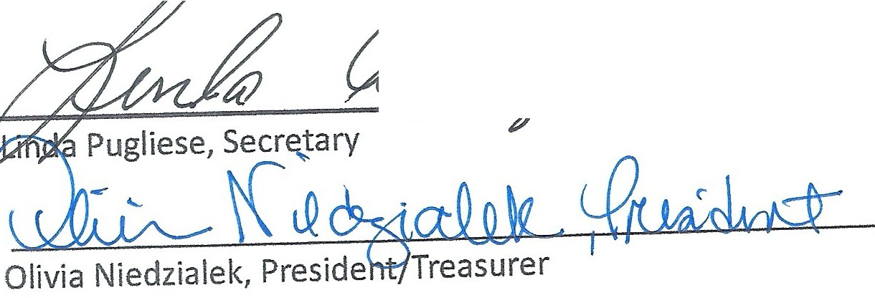
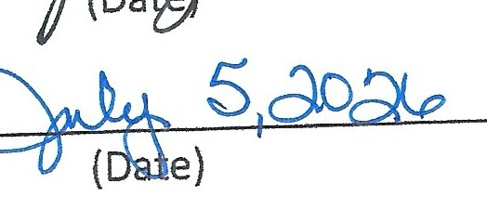
Olivia Niedzialek, President moved to adjourn the meeting if there was no further business. Linda Pugliese, Secretary, seconded the motion. The motion to adjourn the meeting passed unanimously. The meeting
adjourned at :13 PM. � �
2,oU
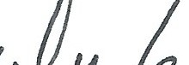

Andres Jordan, Vice President (Date)

Kate Burtsev, Director
&illt-&�

Tuli;;z:;:;k

Mike Lica, Director
(Date)
o�/ oh/ zoz,{p
(Date)
7/�/4.b
(Date)

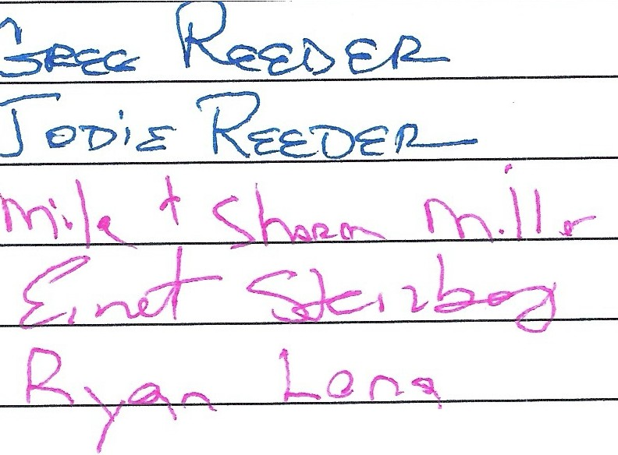
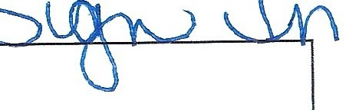
V
I

CYPRESS LAKES HOMEOWNERS' ASSOC., INC.
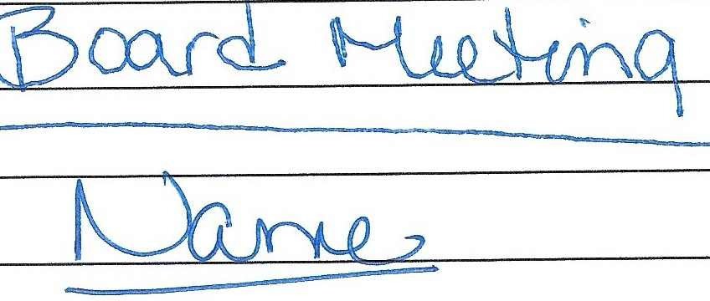
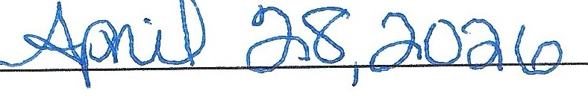
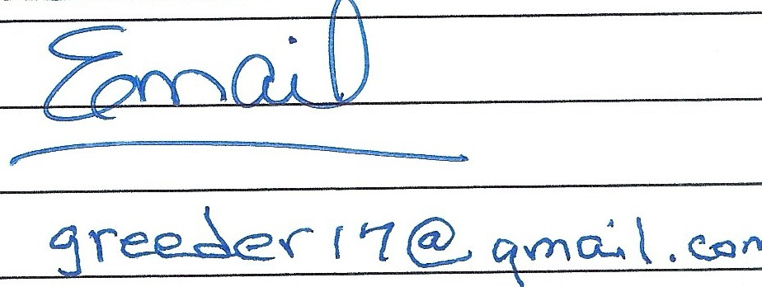
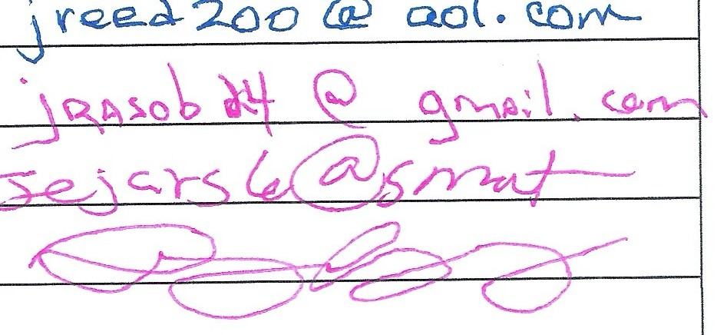
TYPE OF MEETING
DATE

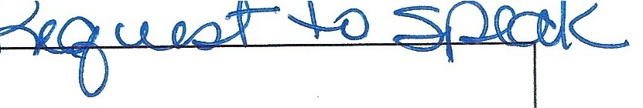

CYPRESS LAKES HOMEOWNERS' ASSOC., INC.

.-�
 | TYPE OF MEETING | DATE
 | w-d 0� | l �-l� �<? �{),Clln
 | <. ) | - '
 | l\ )f\1�1 | f;:_mo.. i 0
 | �1-Z: �<e.£'D'E/2... | \ ree.6 '2.oo@..o...o� .e.o .._

